**BEING WOMAN**

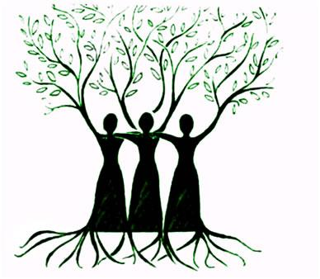

What is a woman? A woman is defined as an adult human female. But one sentence can’t do justice to the meaning of woman. A woman is a person who starts loving her baby even when she has not seen it. A woman is someone who can sacrifice all her dreams and ambitions for the people she loves. A woman is someone who overthinks and gets upset at small things. She is the one who creates a generation after her!  
  
But in the recent times I’ve observed that a woman is just seen as the “other sex” or the “weaker sex”. She is seen as someone who has to do the chores and is considered as an object to be used when out in the public. Instead of respecting women, people eye them as an object of pleasure and entertainment. Her success is always eyed suspiciously by the people.  
  
A woman’s life is never her own. Her life is her parents’, relatives’, siblings’ and even the society’s, but never hers! If a woman is not married, it is her fault. If she overcomes her past, she is heartless. If she is raped, she is inviting. If she cries, she is weak. If she doesn’t, she is made of stone. If she’s career oriented, she is a bad example, if she is a homemaker, she is dumb.  
  
As Louisa May Alcott has written in her novel, “Little Women”, ‘When women are the advisors, the lords of the creation don’t take the advice till they have persuaded themselves that it is just what they intended to do. Then they act upon it, and, if it succeeds, they give the weaker vessel half the credit of it, if it fails, they generously give her the whole’.  We women always get half the credit but the complete blames is on us.  
  
Being a girl, being a woman is a terribly difficult task in this male oriented society, always having to overcome the prejudices and judgments of the society. But yes, I do have hope. All hope has not been lost yet. I hope that in the near future we won’t have to prove ourselves every step of the way and we are treated in that way which we deserve.  
  
Stefan Zweig said that, “Whatever a woman’s reason may say, her feelings will always tell her the truth.” And hence I feel that maybe someday we will be respected for who we are and not what everyone expects us to be.  
  
-Priyanka